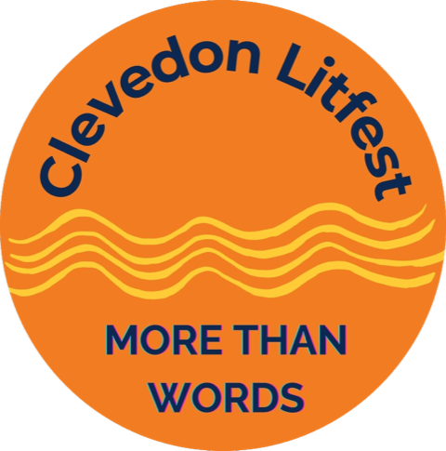 | Job title: Marketing Coordinator (predominantly home-based)  Contract: One year, totalling 156 hrs, variable by mutual agreement  Salary: £15 per hour (£2,340 total)  Role: Marketing, digital and print media  Contract: Freelance  Closing date: 01/07/2024  Location: Clevedon area
Overview
Clevedon LitFest, a vibrant and growing local arts organisation, is seeking a Marketing Coordinator, to play a key role in devising and implementing marketing campaigns for our year-round programme. We encourage applications from residents of Clevedon and North Somerset.

Our current activities include a Summer Festival of 2-5 days in June, annual writing competitions, seasonal events for children, an autumn 1-day event (currently 'Celebration of the Book'), and a promenade theatre event involving local schools.

The post-holder will work under instruction from the Board of Trustees and in tandem with the Programme Coordinator. This is a freelance, part-time role, working mainly from home, with some meetings and activities elsewhere in Clevedon, occasionally during evenings and weekends.

Applicant profile
A highly motivated, well-organised, conscientious and friendly person, willing to work on their own initiative, as well as part of a small team, in a dynamic and fast-developing organisation.

Essential abilities/qualifications:
- Strong copywriting and proofreading skills
- Excellent organisational skills
- Experience in updating and managing websites
- Meticulous accuracy and attention to detail
- Strong IT skills and ability to learn new software
- Ability to juggle multiple tasks
- Minimum 2 years marketing experience, preferably in the arts
- Strong communication skills
- Applicant must have the right to work in the UK

Preferred abilities/qualifications:
- Knowledge and passion for the arts and literature in particular
- Experience using graphic design software

Job responsibilities
- Devising marketing campaigns for an annual programme of events
- Production coordination of seasonal brochures and other publications
- Copywriting: newsletters, social media content, press releases
- Creating, proofing and editing print and online content; ensuring branding guidelines are maintained
- Managing social media accounts and creating compelling content to maintain existing and attract new followers
- Creating website content, including image editing
- Managing the bespoke LitFest website, ensuring it is kept up-to-date
- Developing PR opportunities and relationships with local press/broadcast media
- Other activities as needed, commensurate with the role

How to apply:
Email your CV and a covering email, outlining how you would approach and manage this role, to Jayne Linington at communications@clevedonlitfest.org.uk

